EMULATOR-TRANSLATOR AS METHODOLOGY

Introduction

Illustration 1 shows a conceptual diagram for the Emulator-Translator as a methodology [E-T Methodology]. Three platforms are illustrated:

- The C++ Platform for the local and remote OpenCog Server, a work in progress provided by the OpenCog Project [ http://wiki.opencog.org/w/The_Open_Cognition_Project ].
- The Java Platform for the development of the AGI Object Model that will be described in more detail in the next section.
- The Implementation Platform that consists of the physical hardware for the Local Mind OS on a Hybrid Intelligent PC. The Local Mind OS will be described in more detail in a later section.
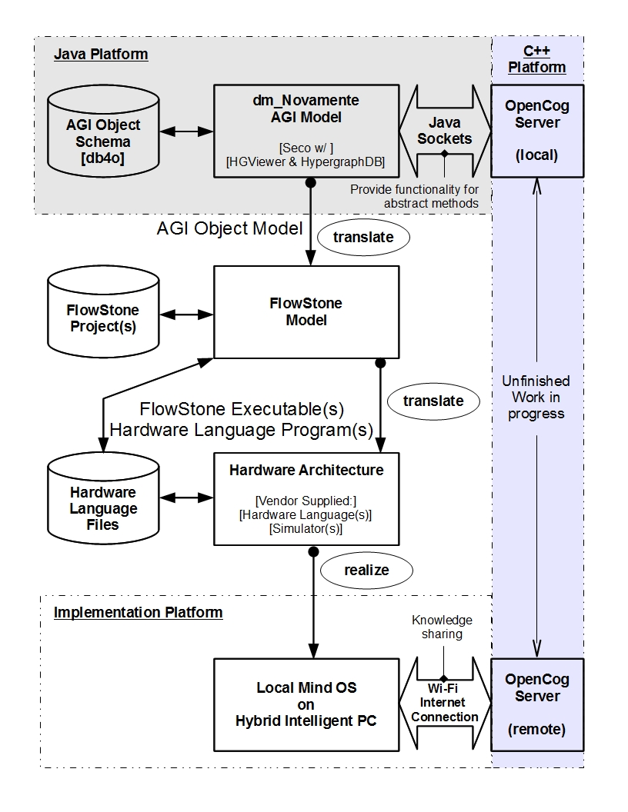Illustration 1: Emulator-Translator as methodology.
The FlowStone Model and Hardware Architecture translate the abstract AGI Object Model into the physical hardware architecture to realize the implementation of a Local Mind OS.

FlowStone Model: The abstract AGI Object Model is translated into an equivalent hardware implementation using the FlowStone graphical programming language from DSP Robotics [ http://www.dsprobotics.com ]. The database storage for the FlowStone Model contains FlowStone Project files. The outputs of the FlowStone Model are compiled FlowStone executable modules and hardware language programs that are generated for vendor specific hardware components. The main goal of the FlowStone Model is to implement a combination of PLN and hBOA as one of the suggested ideas from OpenCog. One possible approach to this is to replace the Markovian network of PLN with a Bayesian network. The FlowStone Model can be implemented on dedicated hardware by using FlowStone Embedded from DSP Robotics [ See http://www.dsprobotics.com/embedded.html ].

Hardware Architecture: FlowStone executables and hardware language programs are stored in the database for Hardware Language Files. This database provides input/output for the Hardware Architecture. The Hardware Architecture consists of vendor supplied hardware language compilers and software to simulate the targeted hardware.

The E-T Methodology is a revision of the original Emulator/Translator framework presented in a previous doctoral dissertation. [ “Novamente artificial general intelligence: Design science research towards a designing / prototyping model”, ref. http://gradworks.umi.com/34/81/3481012.html ] Refer to this dissertation for more in-depth detail of the concepts covered in the description of this revised framework.
dm_Novamente AGI Model

The dm_Novamente AGI Model is produced by a Java application developed on the Java Platform in Illustration 1. The Java application will incorporate the following Java libraries for visualization of atom spaces:

- Seco [ http://www.kobrix.com/seco.jsp ].
- HypergraphDB [ http://www.kobrix.com/hgdb.jsp ].
- HGViewer [ http://code.google.com/p/hypergraphdb/wiki/HGViewer ].

The dm_Novamente AGI Model application will also incorporate db4o [ http://www.db4o.com ] as a built-in object oriented database management system. The application will communicate with a local OpenCog Server using Java Sockets. The OpenCog Server provides functionality for abstract methods In the objects shown in Illustrations 2 and 3. The output of the application is the AGI Object Model.

The AGI Object Model is an Atom centered architecture derived from the OpenCog Project [ http://wiki.opencog.org/w/The_Open_Cognition_Project ]. The derived architecture is shown in Illustrations 2 and 3.

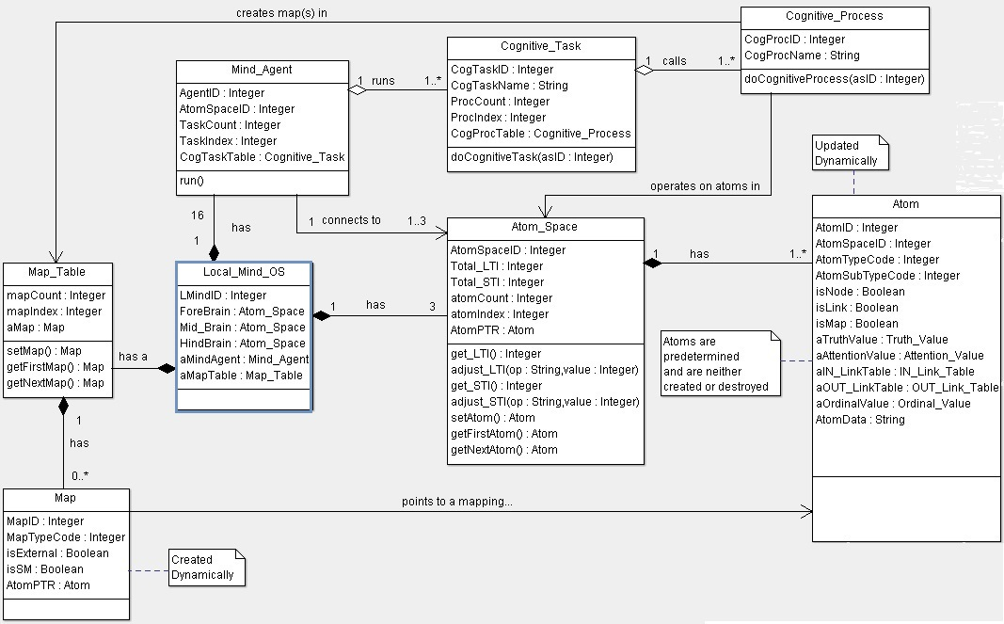Illustration 2: Atom centered architecture - Mind OS components interacting with an Atom.
Illustration 2 is an UML object diagram showing how the Mind OS and its components interact with the Atom object. The Atom object acts as a data object providing all the data needed for a Cognitive Process to operate on it. As shown in Illustration 2, the Local Mind OS is the central object having the following aggregated sub-objects:

- Three Atom Spaces.
- Sixteen Mind Agents running concurrently.
- A Map Table of aggregated Map objects.

Each Mind Agent contains an aggregated table of Cognitive Tasks. Each Cognitive Task contains an aggregated table of Cognitive Processes. The Mind Agent object runs each Cognitive Task in its table and each Cognitive Task calls each Cognitive Process according to its table. The Atom Space acts as a central access point to all Atoms by Cognitive Processes. A Cognitive Process dynamically creates Map objects in the Map Table. Each Mind Agent can be connected to only one or all three Atom Spaces. Each Atom Space contains an aggregate table of Atoms.

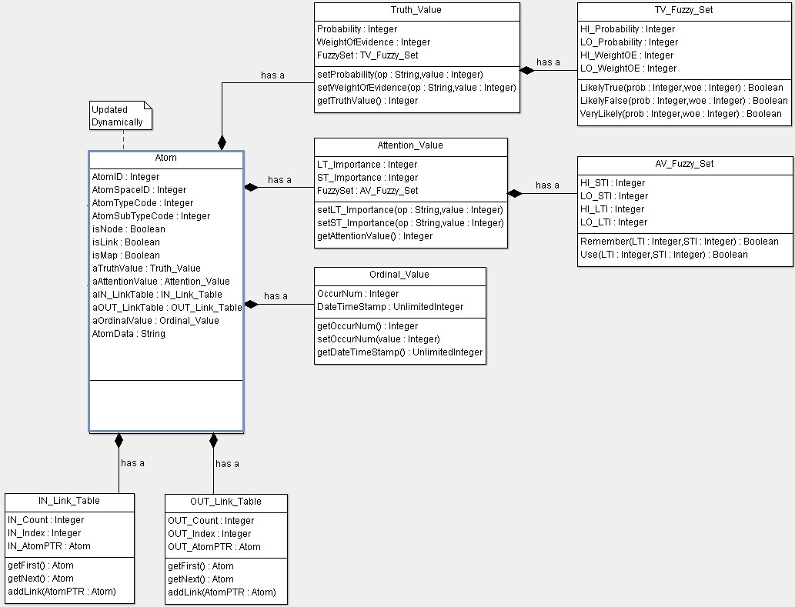
Illustration 3: Atom centered architecture - the Atom and its aggregate components.
Illustration 3 is an UML object diagram showing the Atom with its aggregate components:

- Truth Value sub-object with a Truth Value [TV] fuzzy set.
- Attention Value sub-object with an Attention Value [AV] fuzzy set.
- Ordinal Value sub-object.
- IN Link Table sub-object.
- OUT Link Table sub-object.

Atoms are predetermined in the design of a Local Mind OS. While they are neither created or destroyed, their data fields are initialized by Cognitive Processes when they dynamically update new atoms.

Local Mind OS on Hybrid Intelligent PC

Illustration 4 shows a conceptual diagram of the Local Mind OS. The Local Mind OS is the end product of the E-T Methodology that will be part of a Hybrid Intelligent PC as shown in Illustration 1. The Local Mind OS will be capable of sharing knowledge over a Wi-Fi internet connection with a remote OpenCog Server.

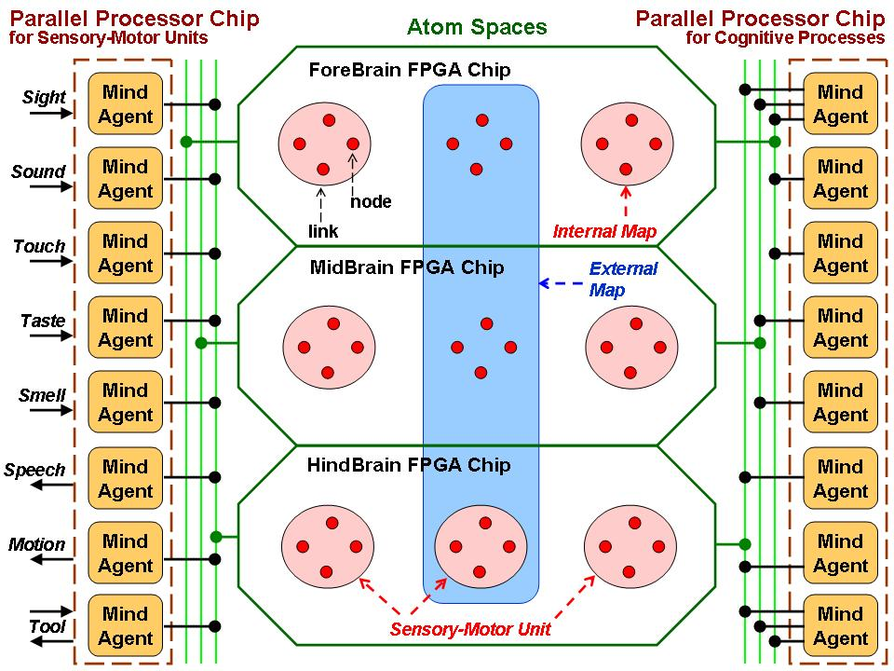Illustration 4: Conceptual diagram for Local Mind OS.
As shown in Illustration 4, the Local Mind OS is composed of three FPGA chips and two parallel processor chips. Each FPGA chip serves as the Fore-Brain, Mid-Brain, and Hind-Brain respectively. Each FPGA chip functions as an Atom Space containing Internal Maps within an Atom Space and External Maps that cross Atom Spaces. Each Map is composed of atoms, that are either nodes or links, and other maps. These FPGA chips are connected via a buss to the two parallel processor chips.

One parallel processing chip is dedicated to eight Mind Agents that act as Sensory-Motor Units. Each Mind Agent within this chip is a parallel processor that operates on only one sensory-motor input/output as shown in Illustration 4. The Tool is a specialized sensory-motor unit that deals with input/output coming to or from hardware or software that do pre-processing outside the Local Mind OS. This parallel processing chip is connected only to the Hind-Brain FPGA chip that contains special Internal Maps for sensory-motor units.

The second parallel processing chip is dedicated to eight Mind Agents that run Cognitive Tasks on Atoms. Each Mind Agent within this chip is a parallel processor that calls a Cognitive Process. This parallel processing chip is connected to all three FPGA chips. This permits Cognitive Processes to have access to all Atoms within all Atom Spaces.

Methodology Generalization

The E-T Methodology presented is to be the subject of design-science research and development. The goal of this research and development will be to generalize the E-T Methodology so that the FlowStone Model and Hardware Architecture are not limited to the GenNet and FPGA / Parallel Processor architectures specified in my previous dissertation. The E-T Methodology will be open to other technologies such as:

- The advent of SyNAPSE - IBM neuromorphic machine technology [ See http://www.research.ibm.com/cognitive-computing ], or

- The parallel, neural network, hardware architecture commercially available from CogniMem [ See http://www.cognimem.com ].

The design-science research and development will also explore the possibilities of automating the translate processes shown in illustration 1. These processes will be manual for the first phase of the research and development.

